Design of Tic Tac Toe Problem:

The essence of design is to create a generic interface and classes to be used for playing a game. These classes can be extended as per the requirement of game. Most of the objects are loosely coupled, can be easily extended whenever required in design.

1. Design of classes and interfaces

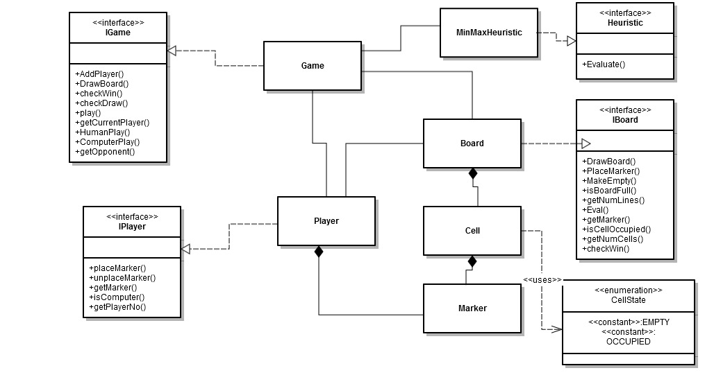

1. Interfaces:

* IGame: This interface provides a generic interface for a playing a game.
* IBoard: This provides a generic interface of kind of board can be used in a game.
* IPlayer: This interface for player playing in a game.
* IHeuristic: This interface for applying heuristic to a game.

1. Classes:

* Game: This class provides an implementation of “Tic Tac Toe” game where all players can participate to play the game.
* Board: This class implements IBoard interface and provide a board to play a game. Board class contains many cells.
* Cell: This class provides cell objects which are contained in a board.
* Marker: This class provides marker objects to a Cell class. Player can place marker on a cell.
* Player: This class implements IPlayer interface. Player class holds player’s properties.
* SimpleHeuristic: This class implements IHeuristic interface and implements “minmax” algorithm.

1. Algorithms:

Game can be played between

Case 1. Human Vs Human

Case 2. Computer Vs Human

Case 3. Computer vs Human

Case 1: is simply placing the marker manually on different cells on a board alternatively by two players.

Case 2 and case 3: uses intelligent “minmax” algorithms to decide the computer move. It calculates the scores by analyzing the opponents move well in advance.

<http://en.wikipedia.org/wiki/Minimax>

Steps in implementing the game:

1. Initialize the game using Board and Players. The players and board are passed from outside to make the design more generic and loosely coupled.
2. Once the game is initialized, players can play their move alternately.
3. If a player will be able to put his markers in a line (row, Colum, diagonal), he wins the game, otherwise game will be ended in a draw.
4. Build Instructions:

Project is built with visual studio 2012 compiler directly.